
Sreenidhi Institute of Science and Technology
H.T No
Regulations:
A20
(An Autonomous Institution)
Code No: 8D284 Date: 20-Sept-2021 (FN)

B.Tech I-Year II- Semester External Examination, September - 2021 (Regular)
COMPREHENSIVE VIVA TEST - II (ECM)

Time: 3:00 Hours Max.Marks:70
Note: Answer Any 70 Questions.
Student can solve more than 70 questions, but maximum 70 marks will be awarded.
Calculator's are not allowed.

S.No | Question
1. | The Differential equation 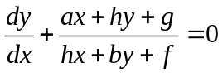 is  a) Homogeneous b) Variables Separable c) Exact d)None of them
2. | The general solution of 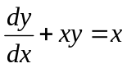is  a) 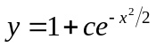 b) 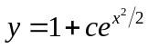 c) 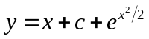 d) None
3. | Integrating factor of 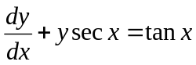is  a) secx + tanxb)secx- tanxc) sec²xd) None of them
4. | The value of 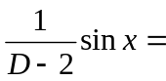  a) 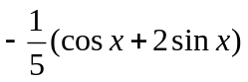 b) 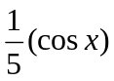 c) 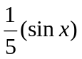 d) 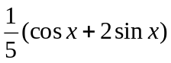
5. | The particular integral of (D+1)²y = x is  a) x b) x – 2 c) (x + 1)² d) (x + 2)²
6. | 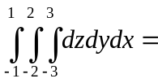  a) 12 b) 24 c) 48 d) 36
7. | The Value of 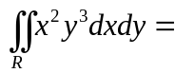 where R is the region bounded by the rectangle 0 ≤ x ≤ 1 and 0 ≤ y ≤ 3  a) 27/4 b) 27/8 c) 29/4 d) 29/8
8. | The prefix equivalent of the infix expression a+b+c+d is _____.  a)+ab+c+d b) +++abcd c) ++ab+cd+ d)abcd++++
9. | What data structure is used to perform recursion?  a) Stack b)Queue c) Linked List d) Arrays
10. | Which data structure is needed to convert infix notation to postfix notation?  a) Branch b)Queue c) Tree d) Stack
11. | What are the operations we can perform on linked lists  a) Insertion b)Deletion c)Traversing d)all
12. | A singly linked list is also called as  a) linked list b)one-way chain c)two-way chain d)right link
13. | The node that has no children is referred to as  a) parent node b)Root node c)leaf node d)sibblings
14. | A Binary tree in which all the leaves are on the same level is called as  a) complete binary tree b)Strict binary tree c)Binary tree d)Full Binary tree
15. | A tree with n vertices consists of --------- edges  a) n-1 b)n-2 c)n d)logn
16. | The word Communication is derived from ________________.  a) Latin b) French c) German d) British
17. | ____________ is the process of changing the information into some form of logical and coded message.  a) Ideation b) Encoding c) Transmission d) Decoding
18. | _______________ takes place between professional peer groups or people working on the same level of hierarchy.  a) Downward communication b) Upward communication  c) Horizontal communication d) Diagonal communication
19. | Everyone agrees with him ________ not me.  a) so b)and c)as d)but
20. | Even when you’re silent, you’re still communicating _____________.  a)extempore b)verbally c)non-verbally d)quickly
21. | ______________ save the kitten, we took him to the vet immediately.  a) Because b)Since c)In order to d)When
22. | _____________ are personality traits and behaviors.  a) Hard skills b)Working skills c)Soft skills d)Attitude skills
23. | _____________ is copying how a native speaks.  a) Speech shadowing b)Learning c)Speaking d)Listening
24. | In Just a minute or JAM session _______________ is not acceptable.  a)thinking b)repetition c)rewarding d)comprehension
25. | You listen in order to understand the main idea of the text. This type of listening is _______________.  a) listening for specific information b) listening for detailed information  c) listening for gist d) listening for pleasure
26. | The species which does not show paramagnetism is  (a)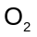 (b)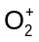 (c)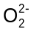 (d) 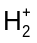
27. | Which of the following is a biodegradable polymer?  (a) PVC (b) Polyethene (c) Nylon-6 (d) Cellulose
28. | When rubber is stretched and then released, it comes to its original position due to  (a) dipole- dipole forces (b) covalent bonding (c) hydrogen bonding (d) cross-links
29. | The metal near to the bottom of the electrochemical series are  (a) Weak oxidizing agent (b) weak reducing agent (c) Strong oxidizing agent (d) strong reducing agent
30. | An electrode is referred as reference electrode because of  (a) Variable electrode potential (b) changes with temperature  (c) Reliable and definite electrode potential (d) potential value depends on the other electrode
31. | Electrochemical corrosion can occur only if  (a) The liquid medium in contact with metal (b) O₂ in contact with metal  (c) Air in contact with metal (d) CO₂ in contact with metal
32. | Alcohol that does not undergo oxidation is  (a) Methyl alcohol (b) 1° alcohol (c) 2° alcohol (d) 3° alcohol
33. | Shape of p-orbital is like that of a  (a) Dumb-bell (b) Sphere (c) Cylinder (d) Ellipse
34. | Mode of excitation of molecule in IR spectroscopy is  (a) electronic (b) vibrational (c) magnetic (d) optical
35. | The metal at the top of electrochemical series is  (a) Most stable (b) best protective (c) most noble (d) most active
36. | Caustic embrittlement is a type of  (a)Boiler corrosion (b) Conditioning (c)Scale formation (d)Sludge formation
37. | The metal at the top of electrochemical series is  a) Most stable b) best protective c) most noble d) most active
38. | Carbonyl compounds especially ketones undergo reduction to form  a) Primary alcohols b) Secondary alcohols c)Alkanes d) Alkenes
39. | Hard water can be softened by passing it through_____  a) Limestone b)sodium hexa metaphosphate c) Ion –exchange resign d) sodium silicate
40. | Which of the following is not an internal treatment method  a) Colloidal conditioning b) Zeolite process (c) Phosphate conditioning (d) carbonate conditioning
41. | Peter is twice as good as workman as Tom. When they work together they can finish a task in 16 days. If Tom works alone, in many days he will complete the task?  a .46 days b.48 days c.50 days d.52 days
42. | A train moving at speed of 90 km/hr crosses a pole in 7 seconds. Find the length of the train.  a.150 m b.165 m c.175 m d.170 m
43. | A can do a job in 12 days and B can do the same job in 10 days. With the help of C they can do the same job in 4 days. In how many days C alone can do this job?  a.15 days b.14 days c.13 days d.12 days
44. | A shopkeeper bought a watch for Rs. 1200. At what price should he sell the watch to earn a profit of 25%?  Rs. 1400 b.Rs. 1450 c.Rs. 1500 d. Rs. 1550
45. | 35,106,317,952, __________.  (a) 1843 (b) 1849 (c) 2851 (d) 2855
46. | FHKN: HJMP :: KRWZ : ?  a) CEGI b) MTYB c) QTVX d) GIKM
47. | The time on the watch is quarter to three. If the minute-head points to North-East, If the minute- hand points to North-East, in which direction does the hour hand point?  (a) South-West (b) South-East (c) North-West (d) North-East
48. | Pointing to a photograph of a boy Suresh said, "He is the son of the only son of my mother." How is Suresh related to that boy?  (a) Brother (b) Uncle (c) Cousin (d) Father
49. | A sum of money at simple interest becomes Rs. 3000 in 2 years and Rs. 3540 in 5 years. Find the rate of interest.  a. 4 % b.4.5 % c.5% d.6%
50. | I travel the first part of my journey at 40 kmph and the second part at 60 kmph and cover the total distance of 240 km to my destination in 5 hours. How long did the first part of my journey last?  a) 4 hours b) 2 hours c) 3 hours d) 2 hours 24 minutes
51. | In seven given numbers, the average of first four numbers is 4 and that of the last four numbers is also 4. If the average of these seven numbers is 3, the fourth number is  a. 3 b. 4 c. 7 d. 11
52. | Mr.Ramu’s mother’s father-in-law’s only son’s only daughter’s son is Chetan. How is Ramu related to Chetan?  a. Uncle b. Nephew c. Niece d.Father
53. | The salary of all officers is increased twice successively by 20%. What is the net percentage increase in their salaries?  a. 20% b. 40% c. 21% d. 44%
54. | Due to fall in manpower , the production in a factory decreases by 40%, By what percentage should the working hours be increased to restore the original level of production?  a. 66 2/3 % b. 46 1/3 % c. 25% d. 40%
55. | By walking at 3/4th of his usual speed, a man reaches office 20 minutes later than usual. What is his usual time?  A) 30 min B) 60 min C) 70 min D)50 min
56. | In the ________ traversal we process all of a vertex’s descendants before we move to an adjacent vertex  a) Depth First b) Breath First c) With First d) Depth Limited
57. | The property of binary tree is  a) The first subset is called left subtree b) The second subtree is called right subtree  c) The root cannot contain NULL d) The right subtree can be empty
58. | If the sequence of operations (push(1), push(2), pop, push(1), push(2), pop, pop, pop, push(2), pop), are performed on a stack, the sequence of popped out values are _____.  (a) 2, 2, 1, 1, 2 (b) 2, 2, 1, 2, 2 (c) 2, 1, 2, 2, 1 (d) 2, 1, 2, 2, 2
59. | Which of the following data structures is linear type?  a) Graph b) Tre c) Binary Tree d) Stack
60. | The way in which the data items are logically related defined  a) Storage structures b) data structures c) data relationship d) data operation
61. | Minimum number of fields in each node of a doubly linked list is ____  a) 2 b) 3 c) 4 d) None of the above
62. | A linear list in which each node has pointers to point to the predecessor and successors nodes is called as…  a) Singly linked List b) Circular Linked List c) Doubly Linked List d) Linear Linked List
63. | The disadvantage in using a circular linked list is _____  a) It is possible to get into infinite loop b) Last node points to first node  c) Time consuming d) Require more memory space
64. | Apply Quick sort on the given sequence 17, 21, 24, 16, 19, 14, 13, 22. What is the sequence after first phase, pivot is first element.  a. 13, 14, 16, 17, 19, 21, 22, 24 b. 16, 13, 14, 17, 19, 24, 21, 22  c. 14, 13, 16, 17, 24, 19, 22, 21 d. 16, 13, 14, 17, 22, 21, 19, 22
65. | What is the worst case time complexity of heap sort algorithm?  a. O(n²) b. O(n) c. O(n log n) d. O(log n)
66. | Which of the following algorithm is best suited if the elements are already sorted.  a. Heap Sort b.Quick Sort c. Selection Sort d. Insertion Sort
67. | Which of the following features must be supported by any programming language to become a pure object-oriented programming language?  a. Encapsulation b. Inheritance c. Polymorphism d. All of the above
68. | What is will be the output of the following programs:  #include <iostream>  using namespace std;  class A  {  public:  A()  {  cout<<"Default Constructor called\n";  }  A(int a)  {  cout<<"Perameterized Constructor called\n";  }  };  int main()  {  A a(12);  A b(25);  return 0;  }  - Default Constructor called  Default Constructor called  - Default Constructor called  Parameterized Constructor called  - Parameterized Constructor called  Parameterized Constructor called  - Error.
69. | Which of the following statement is not true about C++?  a. Members of a class are public by default b. A class cannot have the private members  c. A structure can have the member functions d. All of the above
70. | What will be the output of the following program:  #include <iostream>  using namespace std;  class ABC  {  inta,b;  public:  ABC(inta,int b)  {  this->a=a;  b=b;  }  void display()  {  cout<<endl<<a<<" "<<b;  }  };  int main()  {  ABC ob(25,82);  ob.display();  }  - 25 82  - Garbage value Garbage value  - 25 Garbage value  - Compilation Error
71. | The general solution of 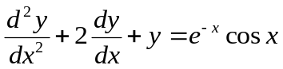is  a) 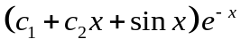 b)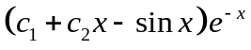 c)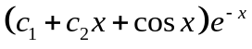 d)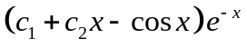
72. | What is the wronskian of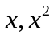  a) 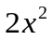 b) 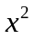 c) 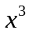 d)
73. | If x = u(1 + v) and y = v(1 + u) then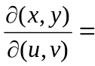  a) 1 – u – v (b) u + v (c) 1 + u + v (d) u - v
74. | If U = x³ + y³ then the value of 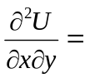  (a) – 3 (b) 3 (c) 0 (d) 3x + 3y
75. | The differential equation 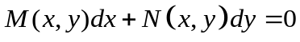is an exact equation if  a)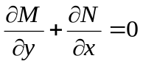 b)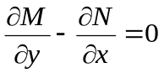 c)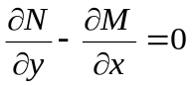 d)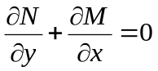
76. | The integrating factor of 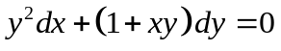is  a) 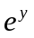 b)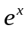 c)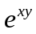 d)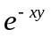
77. | If the rate of growth is proportional to the amount x of the substance present and if 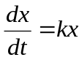then x is equal to  a) 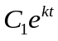 b)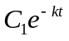 c)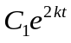 d)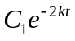
78. | Every polynomial of degree ‘n’ has exactly ______________roots.  a) 1 b) n c) n+1 d) None of these
79. | Root of f(n) lies between a and b if  a) f(a) = f(b) b) f(a) f(b) >1 c) f(a) f(b) = 1 d) f(a) f(b) <1
80. | Newton – Raphson Method fails when  a) 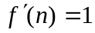 b) 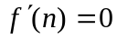 c) f’(x) = 0 d) f(n) =1
81. | The first backward difference in 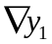between y₀ and y₁ is  a) y – y₀ b) y₁-y₀ c) y₀ – y d) y₁ – y₂
82. | In notation form (1+Δ)y₀ =  a) y₀ b) y₁ c) y₂ d) y₃
83. | 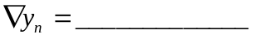  a) y_{n} – y_{n-1} b) y_{n} + y_{n+1} c) y_{n} + y_{n+2} d) y_{n+1} + y_{n-1}
84. | The General formula y_{n+1} = y_{n} + hf(x_{n}, y_{n}) is used in  a) Taylor’s method b) Picard’s method c) Newton-Raphson method d) Euler’s method
85. | If 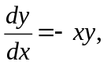 y(0) = 1, then y||(0) =  a) -1 b) 0 c) 3 d) -15
86. | The following is not the property of glass ( )  a)Amorphous Solid b) Very Brittle c)Electric Conductor d)Reflect light
87. | Once cooled and hardened ____________________ plastics and cannot return to their original form.  a) thermosetting plastic b) thermoplastic c) thermostat d) thermocouple
88. | Plastics are made up of__________________  a) carbon b)hydrogen c) oxygen d) all of the above
89. | Welding is applicable for  a) Metals b) nonmetals c) polymers d)ceramics
90. | Punching is _______ operation  a) cutting b) forming c)bending d)deep drawing
91. | Which is not used in preparation of mould  a) Try square b) Pattern c) Core d) Strike-off bar
92. | The cutting tool used in drilling is  a) Multi point cutting tool b)single point cutting tool c)Abrasive tool d) Knurling tool
93. | The full form of CNC is ___________________________  a) computer numerical control b) control numerical computer  c) computer network control d) none of the above
94. | STL stands for ________  a) Standard Transmission Line b) Structured Template Language  c) Standard Training List d)Standard Triangular Language
95. | The tool used for holding the cylindrical work piece is  a) Bench-vice b) C-clamp c) V-Block d) Work bench
96. | The angle of center punch is  a) 90 b)60 c)45 d)75
97. | PCB stands for  a)power circuit board b) program circuit board c) printed circuit board d) pillar circuit board
98. | ----------- prevents the electric shock in the iron box  a)mica sheet b) metal block c) thermostat d) conductor
99. | The file used in carpentry is  a)square file b)triangular file c)half round file d) rasp file
100. | The dark central part of a timber tree is called as  a)heart wood b)soft wood c)pith d)bark

-- 00 -- 00 –

